My questions focused on usability because I wanted to understand how easy the website is to use from a user’s point of view. I also focused on the design to see how users felt about the look and overall appearance of the website. I asked users what they would change if they could because this helps highlight any issues or improvements that might not be obvious at first. I also asked whether users had experienced any errors while using the website so I could identify any problems that might affect their experience.

Analysis of responses
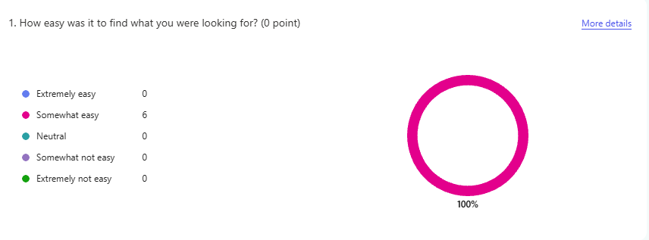
100% of users said the website was somewhat easy to use, although there is still room for improvement in overall usability. One factor that people seemed to struggle on was the booking forms, and the lack of conformation message after booking. I could improve on this by providing a conformation message when booked to avoid confusion.
When asked what the users noticed first on the page the majority of they said the hero image and the title which aligns with the intended design and confirms that the layout is affective.
when users were asked if they found anything confusing with the website some were confused about a css error on the account page and others were confused about the navigation bars options as they were not sure where each of the options would take them this could be combatted by expanding on the options on the top bar with more descriptive names.
When asked what part of the website did you find most useful users mainly said the booking page where they can edit and view their bookings which confirms that they appreciate this feature?
When asked what frustrated people the most, 50% of users said they didn’t feel frustrated and others mentioned the following:
. Text size was too small on the educational visit section
. Footer did not stay at the bottom on booking page
. Top bar text was not clear what It lead to
. There was no error message when someone tried to log into an account that does not exist.

